Learning objectives IoT Essentials
What do we want people to know at an 'Essentials' level exam?

The IoT Landscape
There are many ways to visualize the IoT landscape. IoT solutions often start with some sensors that transmit data to the cloud where it is visualized on a dashboard.
Actuators are introduced later on as well as is the storage of data, maybe even 'big data'.
The figure below identifies 7 elements, but just as with the OSI model, these elements can be combined into a single device. As a result the 7 elements are not always clearly visible.
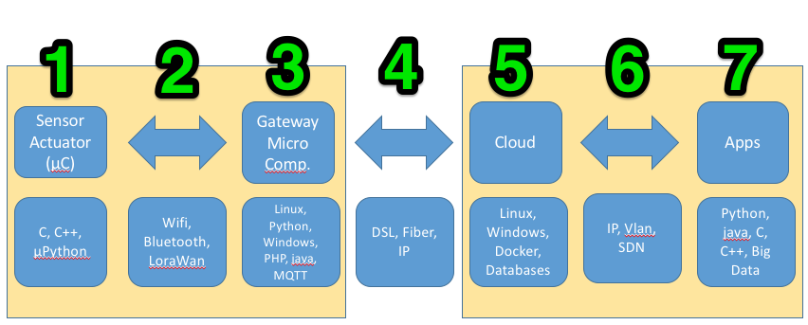
In order to identify what is important to know, what is nice to now etc. we need to explore the characteristics of the areas in more detail.

1. Sensors and actuators
Sensorsare collecting information, such as temperature, vibrations, hart beat rate's etc. And that is all the do, they do not initiate an action, they share the information so that decisions can be made either at the level of the gateway/controller, or even in the cloud. Actuators perform an action, e.g. a light get's switched on, the speed of a motor is adjusted etc. They are often connected to micro-controllers such as Arduino's, ESP8266 etc.
From an electronics point of view there are many way's to connect sensors and actuators. There are analogue sensors and digital sensors. The same goes for actuators.

Analog sensors and actuators
Analog sensors change the voltage that is fed into the micro-controller. The micro-controller reads this value and converts it to a digital value.
With analogue actuators the micro-controller sends an analogue value which determines the behavior of the actuator. This could be used to control the intensity of a lamp etc.

Digital Sensors and actuators
On/Off
Digital sensors use a variety of techniques to send information to the micro-controller. This can be as simple as a switch (a sensor for keypresses) that sends a digital high (1, true) or low (0, false) signal.
Digital actuators receive digital information from the micro-controller and will respond with an on/off action.
1-Wire
A bit more complex is the usage of a 1-wire sensor. Here the sensor sends sequences of digital high and low values that have to be received. After reception of the complete sequence the micro-controller can interpret the information. A well know example is the DHT-11 temperature and humidity sensor.
Actuators received similar information from the micro-controller and act according to the information received.

I²C (aka I2C)
The I²C devices are connected to a digital bus system which consists of 2 wires for exchanging information. One is a clock signal and the clock-rate determines the speed at which information is exchanged. The other one carries the actual information. Device connected to the I²C bus have an address on this bus by which they can be identified.
Other serial protocols
There are other serial protocols that can be used to exchange information or instructions between a micro controller and a device. Examples are RS232 and RS422.

2 Communication between controller and gateway
At the level of the Sensors and Actuators we do not have IP addresses! In order to make the information available to the internet IP addresses are required. The role of the gateway is to convert the information from sensors into something that has an IP address and vice versa for actuators.
Vendors often use the word 'bridge' in their products which is actually a gateway.
The connectivity between a gateway and the device can be hardwired, but also be wireless. Wireless protocols often used are bluetooth, zigbee, z-wave and LoraWan. Of course there are differences between the protocols. Some are very energy efficient, some can transmit data over long distances. Some can build mesh networks others can't. There is also a difference in bandwidth and reliability of the wireless connection. Most of these connections are not permanent, but ad-hoc connections.

3 Gateways
Gateways ar the IP endpoints for sensors and actuators. They exchange information with the cloud but also can contain logic to make decisions and initiate actions. In that sense they are controllers as well.

